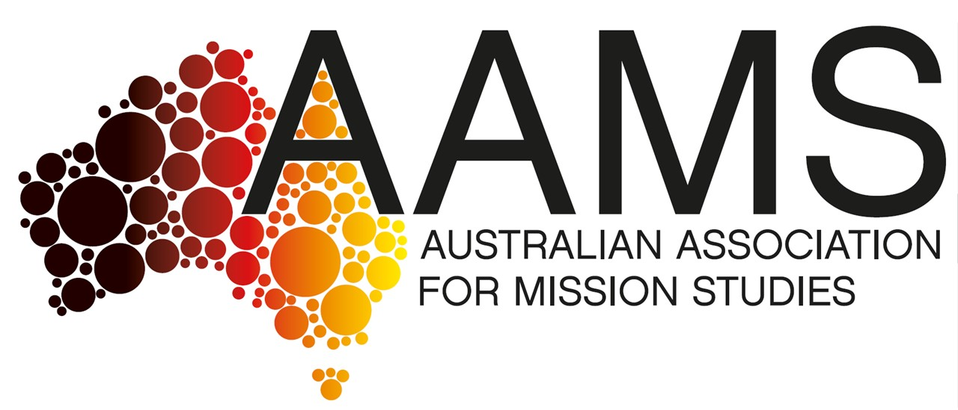

2025 ANNUAL GENERAL MEETING OF THE AUSTRALIAN ASSOCIATION FOR MISSION STUDIES

The AGM will be held at Dorish Maru College, 100 Albion Road, BOX HILL in person and via ZOOM
on Thursday 27 November 2024 at 4.30pm (AEDT).
All Members are invited to attend the AGM in person, or via this ZOOM link:
https://divinity.zoom.us/j/6026675289?pwd=SmY5YTlsWkN6QlhVSkxtZWFyV3ZOQT09
Meeting ID: 602 667 5289
Passcode: 089277
Brisbane Time: 3.30PM to 5.00PM (AEST)
Sydney/Melbourne/Hobart Time: 4.30PM to 6.00PM (AEDT)
Adelaide/Darwin Time: 4.00PM to 5.30PM (AEDT)
Perth Time: 1.30PM to 3.00PM (AWST)
Auckland NZ Time: 6.30PM to 8.00PM (NZDT)

Rules of AGM:
35. Use of technology
(1) A general meeting may be held and members may take part by the use of technology that allows members to clearly and simultaneously communicate with each other participating member.
(2) For the purposes of this Part, a member participating in a general meeting as permitted under subrule (1) is taken to be present at the meeting and, if the member votes at the meeting, is taken to have voted in person.

AGENDA

The ordinary business of the Annual General Meeting shall be:
1. Welcome and Acknowledgment of the Traditional Owners (President, who will chair the AGM)

2. Prayer (President)

3. Rollcall of Members present:
4. Apologies received:

- Acceptance of the Minutes of the 2024 AGM (Minutes attached)
Amendment requested: Rev Dr Xiaoli Yang wishes to confirm that she was present at the 2024 AGM.

Moved: ______ Seconded: ______ Carried:

- To receive from the Committee reports upon the activities of the Association during the preceding financial year:

  - President’s Report for 2024-25

Dear Members,
As we approach our Annual General Meeting on 27 November 2025, I am pleased to present this President’s Report highlighting the activities of the past year, reflections on our mission, and a missional reflection drawn from recent scholarship to inspire our ongoing work.

Committee Meetings
Over the past year, the AAMS Committee has met four times, alongside four meetings of the Australian Journal of Mission Studies (AJMS) Board. We also established a Special Committee, including Society of the Divine Word (SVD) representatives and AAMS members, to organise the significant Missio Dei: An Ecumenical Conversation Conference. This committee met several times during the year to ensure the success of this important gathering.

20th Anniversary of AAMS Foundation (2026)
Next year marks two decades since the formation of the Australian Association for Mission Studies. The first Committee meeting was held on 6 February 2006, following the 2005 decision to relocate and rename the organisation. We will celebrate not only our inaugural meeting but also our formal constitution and legal incorporation milestones. Incoming President Helen Stewart and the Committee are considering plans to mark these significant anniversaries. The June 2026 edition of the AJMS will also honour these milestones.

EBSCO Licence Agreement
In April 2025, the AJMS Board was presented with a proposal by EBSCO to establish a licence agreement for journal distribution. After careful consideration, the AAMS Committee unanimously agreed to proceed. Our Secretary, Janette Elliott, signed the agreement on 15 October 2025, and we await EBSCO’s signature to finalise the process. This agreement will enhance the accessibility and reach of our journal content.

Missio Dei: An Ecumenical Conversation Conference
Held on 2-3 October 2025 at St Paschal’s Chapel and Yarra Theological Union, this collaborative SVD/AAMS conference celebrated the 150th anniversary of the Divine Word Missionaries. It featured keynote presentations from Antonio Pernia SVD, Glen O’Brien, Vicky Balabanski, and Susan Pascoe, among others, focusing on the contemporary understanding of Missio Dei and ecumenical engagement. The event concluded with a Eucharist celebrated by Archbishop Doug Young SVD and a formal dinner at Dorish Maru College.

AAMS Website and Digital Presence
The cost of maintaining our website with Heartburst has been considerable. Thanks to the introduction by former President Sandy Boyce, we have transitioned web hosting and maintenance to Rev Geoff Hurst of Uniting Vision, who offers a more cost-effective service. Heartburst continues to manage the domain registrations. This change took effect immediately after our August 2025 Committee meeting. Our Facebook page remains under review for its role in member engagement.

Patrick McInerney SSC Award
We warmly congratulate Rev Dr Patrick McInerney SSC, a former AAMS President, on receiving the inaugural Interfaith Dialogue Award from the University of Notre Dame Sydney. This honour recognises his longstanding commitment to fostering understanding between Christians and Muslims.

Chris Ponniah in New Zealand
Former Secretary Rebecca De Jong introduced us to Rev Chris Ponniah, an Anglican priest serving immigrant communities in Christchurch, New Zealand. Chris’s work with diverse faith groups, including Sikh, Hindu, and Muslim communities, enriches our understanding of mission in multicultural contexts. Chris will be giving us a presentation at this AGM from New Zealand. Thank you, Chris.

Expression of Thanks
I extend my sincere gratitude to all members for your ongoing support and engagement. Your commitment sustains AAMS as a vibrant network for mission studies in Australia and beyond.
In reflecting on our mission today, I draw upon insights from the recent reprint of a 1974 study on future mission challenges (The Way, January 2024). The document highlights the vital shift from traditional missionary models to empowering local churches to take ownership of their mission and identity. This involves a move away from colonial-era structures toward fostering indigenous theology, spirituality, and leadership that resonate authentically within each culture.
This missional insight calls us to support local communities not simply by providing external leadership or imposing familiar frameworks but by encouraging self-sustaining, culturally grounded Christian communities. It challenges us to be primarily learners (as mission practitioners) as much as teachers, embracing mutual exchange and humility. As Cardinal Zoungrana of Upper Volta stated, missionaries today serve best by changing their mentality to one of service rather than control.
For AAMS, this means fostering scholarship and dialogue that advance indigenisation and lay participation, encouraging mission studies that listen deeply to local contexts, and supporting mission practitioners who embody this spirit of accompaniment and mutuality. This approach resonates strongly with our recent ecumenical conversations and the evolving nature of mission globally.
I invite all members to consider how we might integrate these missional insights into our research, teaching, and practice. Together, we can contribute to shaping a future mission that is both faithful to the gospel and deeply rooted in the cultural life of diverse communities.
Yours in mission,

Albano Da Costa SVD
AAMS President

Acceptance of President’s Report: Moved: Seconded: Carried

  - Secretary’s Report for 2024-2025

In August of 2024 Darrell Jackson conducted a handover of the AAMS Secretary role which took effect officially at the 2024 AGM. Both hard copy and digital files were included in the handover. Dorish Maru was registered as the official AAMS address. With Albano Da Costa, Helen Stewart and Peter Wilkinson I was warmly welcomed to AAMS and I am grateful for the consistent support I have received since this time. We fulfilled out reporting duties to ACNC through the submission of our Annual Information Statement late January.

AAMS Website
In the transition for new executive members changes to the way in which the AAMS website is hosted, managed and maintained took place with Heartburst initially engaged to assist with this. In the interests of time especially in the lead up to the joint SVD- AAMS Conference, Sandy Boyce very generously updated the website. The website was the portal for Conference registrations. With increased and non-viable costs for Heartburst, a further change was made regarding the hosting and maintenance of the AAMS website. The following motion was put forward and accepted unanimously. That the hosting and maintenance of the AAMS website be transitioned from Heartburst to Uniting Vision immediately, but that Heartburst be requested to continue to maintain the registration of the 2 AAMS Domain Names:
www.missionstudies.org.au and www.missionstudies.au

EBSCO Licence Agreement
In August the AAMS Committee unanimously accepted the EBSCO licence agreement and approved Janette Elliott to sign it. Bonnie Tran approached AAMS earlier in the year offering to hold and host the AJMS journals for greater circulation and invite wider scholarly interest.

Joint SVD – AAMS Conference 2-3 October 2025
The Divine Word Missionaries are currently celebrating 150 years in Australia and organised a conference as part of the Jubilee celebrations. AAMS accepted the invitation to jointly host the Conference and contributed financially to it.

Change of Committee Members
Graham Hill withdrew as a member of the AAMS Committee effective 26 August 2025. Peter Wilkinson will/ has sent a letter of appreciation for Graham’s work as former Editor of AJMS and role as a Committee member on the AJMS Board. Chris Ponniah has replaced Rebecca De Jong on the AAMS Committee as the mission liaison person for Mission Interlink New Zealand. However, Rebecca will continue on the Committee of AJMS. Chris was accepted by the AAMS Committee.

Meetings
The AAMS Committee has met four times this year to date (March, April, August and now November). The acceptance of Albano Da Costa for the Doctoral program has been a significant shift in the planned meeting schedule for 2025. Helen Stewart and Peter Wilkinson have worked tirelessly for AAMS this year, as has Michael Kelly AJMS Editor in respective of the Conference and Journal. There contributions deserve real acknowledgment and appreciation. At the time of writing this report I am about to head overseas. I am most grateful to Peter Wilkinson for providing secretarial support during this time, as he has throughout the year.

Janette Elliott
AAMS Secretary

Acceptance of Secretary’s Report: Moved: Seconded: Carried

  - Treasurer’s Report for 2024-25 Financial Year (1 July 2024 to 30 June 2025)

 | Approved  Budget  2024-2025 | Income  & Expenses  1 July 2024 to  30 June 2025 | Draft  Budget  2025/2026
Funds on Hand
Term Deposit (at 30 June 2025) | 13,007.72 | 13,624.27 | 13,624.27
Cash at Call (at 30 June 2025) | 9,825.83 | 8,305.05 | 8305.05
TOTAL FUNDS (at 30 June 2025) | 22,833.55 | 21,929.32 | 21,929.32
INCOME
Memberships & Subscriptions | 8000.00 | 6740.00 | 7,000.00
Interest – Term Deposit | 500.00 | 616.55 | 500.00
Donations
TOTAL INCOME | 8500.00 | 7356.55 | 7,500.00
EXPENDITURE
Printing of Journals (2 editions) & Envelopes | 2500.00 | 2277.00 | 2300.00
Postage (2 editions) | 1400.00 | 777.12 | 1400.00
Website Rego/Maintenance | 200.00 | 4312.00 | 1500.00
Conference | 2000.00 | 0.00 | 2000.00
Annual Lodgement Fees
Journal layout | 500.00 | 716.28 | 500.00
Stripe Fees | 200.00 | 133.37 | 150.00
Miscellaneous |  | 279.00
TOTAL EXPENDITURE | 6800.00 | 8494.77 | 7850.00
PROFIT (LOSS) | 1700.00 | (1138.22) | (350.00
NET ASSETS (at 30 June 2025) |  | 21,929.32

Notes:
- This report covers the full Financial Year period of 1 July 2024 to 30 June 2025.
- In the short period of 11 April 2025-30 June 2025 there was a small income of $780.00 from membership subscriptions and substantial expenses from Heartburst ($2992), Doran Printing ($1056), and Impressum ($231). Stripe Fees were just $17.32.
- At 30 June 2025 total assets were $21,929.32: $8.303.05 in cash at hand and $13,624.27 in the Term Deposit with the Bendigo Bank. This was $906.23 short of the Draft Budget for 2024/25.
- Since 1 July 2024 total income from membership and journal subscriptions has been $6740.00, well short of Budget forecast of $8000.00 due to falling membership and library subscriptions.
- Since 1 July 2024 total expenses have been $8,494.77, almost $1695 over budget projections. A large part was due to the costs of transference, hosting and management to Heartburst ($4312). Other costs were printing ($2277), postage ($777.12), Journal layout ($716.28), Stripe fees ($133.37), and miscellaneous ($279).
- The Draft Budget for 2024/2025 was amended after the meeting on 14 April 2025 to include an allocation of $2000.00 for the SVD/AAMS Conference in October 2025. This money has not been allocated as yet (at 30 June 2025)
- I have prepared a Draft Budget for 2025/2026 which I will present at the Committee Meeting on 11 July 2025.
- Current active member and journal subscriptions are 146: Local – 116; Overseas – 30.
Unrenewed are: 4 – promised to renew; 1 – on hold; 6 expired and to call back.

Peter J Wilkinson
AAMS Treasurer

Acceptance of Treasurer’s Report: Moved: Seconded: Carried

  - Report of Chair of the Board of Australian Journal of Mission Studies for 2024-2025

Two journals have been completed and distributed for the period December 2024 to June 2025.
The December 2024 journal begins with Sr Monica Cavanagh’s article titled ‘Witnessing to the Light-from everywhere for everyone.’ Drawing on scripture and the words of Pope Francis, Sr Cavanagh illustrates using a series of stories of people who have been a source of light in a variety of difficult situations. Within the December journal we have sourced contributions from Asian feminist theologians who offer us insights about sustainable development, social inclusion, ecological justice and migration. Experiences of this land’s First Peoples are included. Ross Mackinnon reviewed the text ‘Community a Church, Church as Community’ and also the text ‘Learning to Love: ‘Utilising Principles and Practices of Pastoral Care for Mission.’

The June 2025 journal offers papers on a diverse range of topics. Kirk J Franklin wrote a thoughtful and challenging paper which addresses the question of the interface between Western missions and the reality of moving to the global South, and Dean Eland offered us an oral memory of the growing ecumenism between the Australian churches. Joy Sandefur’s article titled ‘Some Surprising Outcomes from Translating the Bible into Australian Kriol ’inspires us to reflect. Patrick McInerney offers a thoroughly researched homily on the feast of St Columban, which takes us through the ages of mission and constructively reflects on the contribution of his religious community, the Columban Missionary Society.

Another successful year thanks to the contributions from members of the journal group and other members of the AAMS. However, it is important to note that it is becoming increasingly difficult to source articles, reflections and reviews as a growing number of people are time poor. We are increasingly relying on members of the journal group to compose articles and reviews.

As chair of the journal group I would like to take this opportunity to thank members for their ongoing commitment to attend meetings and actively have input into progressing the journal. I would especially like to congratulate Michael Kelly, our editor. Michael is diligent in communicating with contributors and ensuring that all aspects of the journal are completed within the set time frame.

We look forward to working together as a team to create two more journals for December 2025 and June 2026.

Helen Stewart
Chair, AJMS

  - Reports from State Mission Studies Networks 2024-2025

NSW Report: There is nothing to report. There have been no AAMS NSW activities, meetings, or events in Sydney for the past few years. The only indication of life was an occasional post on the AAMS FB page or an e-mail about a mission-related event being held by some other organisation.

Rev Dr Patrick McInerney, Coordinator of AAMS (NSW)

VIC Report: There have been no activities and meetings in Victoria in the past year. However, a new book Chinese Christian Witness: Identity, Creativity, Transmission and Poetics was published was released this year by Brill (IAMS book series). The IAMS call for papers was sent out via Facebook “Australian Theology Matters”, AAMS membership and various universities and mission networks.

Dr Xiaoli Yang
Victorian Network Coordinator

SA Report – October 2025: Following the 2022 IAMS conference several SA members of AAMS have been involved in developing the SA Church History Network. The SACHN planning group includes several well-known historians from Lutheran, Anglican, Baptist and Uniting traditions. The aim is to promote awareness among church leaders, teachers, students and the general public of the Christian presence in and contribution to South Australian life and history since 1836.

On 17 May this year the Network hosted a half day conference during SA’s History Festival on the topic, “Christian Churches and social welfare in South Australia 1995-2025’. Guest speakers included three former CEOs of Anglicare, Uniting SA and the SA Council of Social Services. Evaluation comments about the session included insights about the changing relationship between services and congregations.
‘Smaller agencies are not able to comply or be viable. Absorbed by larger bodies. Grant-based funding from the government with few strings attached is straightforward and presents few problems. But market-based funding, in which agencies compete, is much harder. Marketing acumen is needed. Staff move to agencies which receive government funding. Loss of connection with local congregations. Church organisations (such as ladies’ guilds) and other voluntary bodies are no longer involved (as they once were) as volunteers to assist church-based agencies.’

The Network is again hosting an all-day conference on 23 May 2027 on the theme ‘Christianity in South Australia, 1945 – c.2000’. During the years between the end of the Second World War and the close of the twentieth century there were major changes in Christianity in South Australia, in both religious adherence and behaviour and within religious institutions. The churches in 2000 were very different from what they were in 1945. Some long-established Christian organisations declined and disappeared while new expressions of Christianity emerged. Conference papers of up to 20 minutes in length (about 2000–2500 words) are invited on any topic related to the theme of the day.

Rev Dr Dean Eland. Secretary.
sachurchhistory@outlook.com

- Financial Statements

To note that as the Association is a tier one association under the Associations Incorporation Act, and to pass the following resolution as an ordinary resolution:

That the financial statements need not be subject to audit or an independent review under the Australian Auditing Standards on Review Engagements.

Moved: Seconded: Carried:

To receive and consider the financial statements of the Association in accordance with section 30(3) of the Associations Incorporation Act for the financial year ended 30 June 2024 submitted by the Committee in accordance with Part 7 of the Associations Incorporation Reform Act and Part 6 of the Rules of the Association.

- Number of Committee Members

To pass the following resolution as an ordinary resolution:

That the number of ordinary members of the Committee be a number determined by the Committee from time to time.

Moved: Seconded: Carried

- Annual Membership Fee

To pass the following resolution as an ordinary resolution: That the membership fee be left unchanged at the current level of $50.00 per annum for members in Australia, and $70.00 per annum for all other overseas countries.

Moved: Seconded: Carried:

- Election of Officers and Committee for 2025-26

President will vacate Chair and Secretary will take the Chair.

- Nominations for Executive Offices (to be received by 25 November 2025)

President
Vice-President
Secretary
Treasurer

- Nominations for Committee Members (to be received by 25 November 2025)

(Treasurer to call for Vote or Declare Nominated Members elected).

Newly elected President will take the Chair and thank outgoing President, Executive and Committee Members for their dedicated service during 2024/2025 and welcome the new Committee Members offering their service for 2025/2026.

The newly elected President will then proceed with the rest of the business.

- To pass the following resolution as an ordinary resolution:

That if, at any time, an officer or ordinary member of the Committee is unable to serve his/her full term, authority is hereby granted to the Committee to appoint any person the Committee considers to be appropriate to fill a casual vacancy. Any person appointed to fill a casual vacancy will be required to stand for election at the next annual general meeting held after his/her appointment.

Moved: Seconded: Carried:

- Close of AGM (new President)

Declare meeting closed.

Presentation

Rev. Christ Ponniah, Director of Missions Interlink New Zealand, will make a presentation.

An AAMS Committee Meeting will immediately follow the AGM

Agenda

- Scheduled Meetings for 2026
- Priority Issues to be discussed
- Resolution with Heartburst financials

Presentation by Rev. Chris Ponniah
Director, Missions Interlink New Zealand

Chris Poniah was born in Sri Lanka and raised in Singapore. Driven by a desire to fulfil the Great Commission, he pursued mission training at WEC Missionary Training College in Tasmania (Australia). It was there that he met Joy, and they married in 1989. They are blessed to have three children and two grandchildren.

Over the past 30 years, Chris has had the privilege of pastoring churches in Singapore, Hong Kong, and New Zealand, where he encouraged a focus on both local and global missions.

In 2022, Chris got involved in training missional practitioners in different countries, taking leave from his pastoral duties to facilitate training courses in those locations. In 2023, whilst he was continuing to train Christ-followers to reach the lost, he also became increasingly concerned about the decline of Christianity and the growing number of migrants in New Zealand. He sensed God leading him to transition from pastoral ministry to a focus on mission and disciple-making. So, in February of this year he took a leap of faith and stepped away from pastoral work to engage more deeply in mission, not knowing what that would entail.

Shortly thereafter, he had the opportunity to collaborate with several mission organizations to support churches in reaching out to migrants in New Zealand. This collaboration resulted in the establishment of the Migrant Alliance and Integration Network. When the Mission Interlink Director position became available, he felt led to apply after prayerful consideration and discussions with his wife. At the same time, he was invited to attend the Lausanne Congress in South Korea, which further expanded his involvement in mission collaboration both regionally and within the Global South. This led him to get excited about the potential Mission Interlink NZ has in being a valuable platform for mission agencies, mission-minded leaders, and Christian organisations to connect, support one another, and collaborate on mission-related challenges and strategies, ultimately acting as a catalyst for mobilising mission efforts in Aotearoa New Zealand.
www.missions.org.nz

History of Missions Interlink NZ

Missions Interlink NZ was founded in October 1972 as the NZ Evangelical Missionary Alliance, a sister organisation to the NZ Evangelical Alliance (now the New Zealand Christian Network, of which we are a member).

Roots of mission in NZ
However, our whakapapa (heritage) extends back to the early 19th century when Christian missionaries from various denominations first arrived in New Zealand, driven by a passion to share the Gospel with the Māori people. Pioneering figures like Samuel Marsden played crucial roles in establishing the first mission stations, and these early missionaries made significant contributions to community development, education, and healthcare, building lasting relationships with Māori communities.

Growth
The establishment of Aotearoa New Zealand was marked by the signing of the Tiriti o Waitangi (Treaty of Waitangi) in 1840, which laid the foundation for partnership between Māori and the British Crown. By 1859, the first overseas missionary committee was formed here, and by 1887, the first New Zealand missionary, Rosalie McGeorge (Baptist), was sent beyond the Pacific. In the same vein, Florence Young established a mission to Solomon Islanders, leading to the South Sea Evangelical Mission (now Pioneers). Over time, the descendants of early settlers and immigrants felt a strong personal call to overseas mission, and by the 1970s, New Zealand was the highest sender of missionaries per capita in the world.

NZ missions Impact
As New Zealand has evolved, so has the landscape of mission. Today, we celebrate diverse cultural expressions of faith and promote indigenous leadership within our mission efforts. The legacy of early missionaries continues to inspire a dynamic mission movement in New Zealand, where believers actively engage both locally and globally to spread God’s love and serve diverse communities.
As missionaries from Aotearoa New Zealand, Mission Interlink and its members embrace our identity as Kiwis commissioned by Christ the King, serving as His ambassadors alongside believers from around the world. Our mission is straightforward: to guide individuals from all backgrounds toward becoming His disciples, enriching their lives and those of their families and communities. This commitment to fulfilling the Great Commission encourages everyone to submit to the King, welcome His Spirit, and embody His Kingdom values. Through these efforts, we bring glory to God—the ultimate purpose of His mission.

Kouratahi Manifesto 2008
Statement of Faith

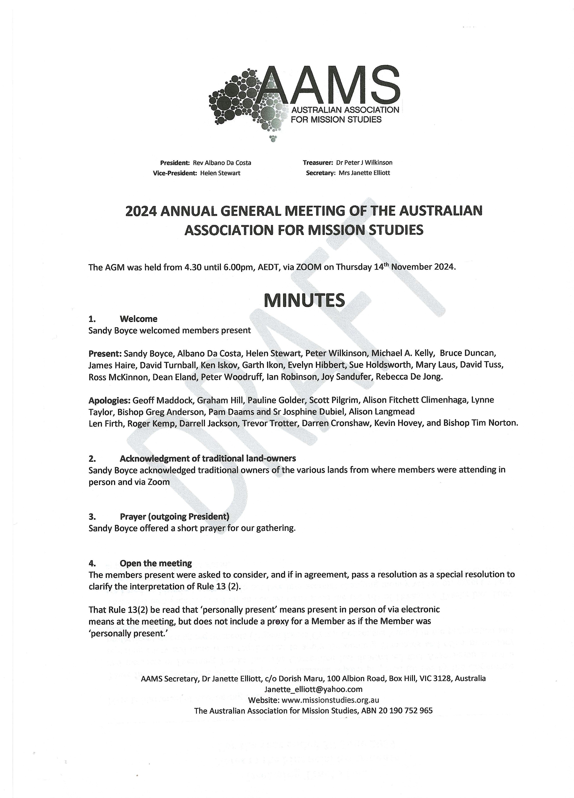

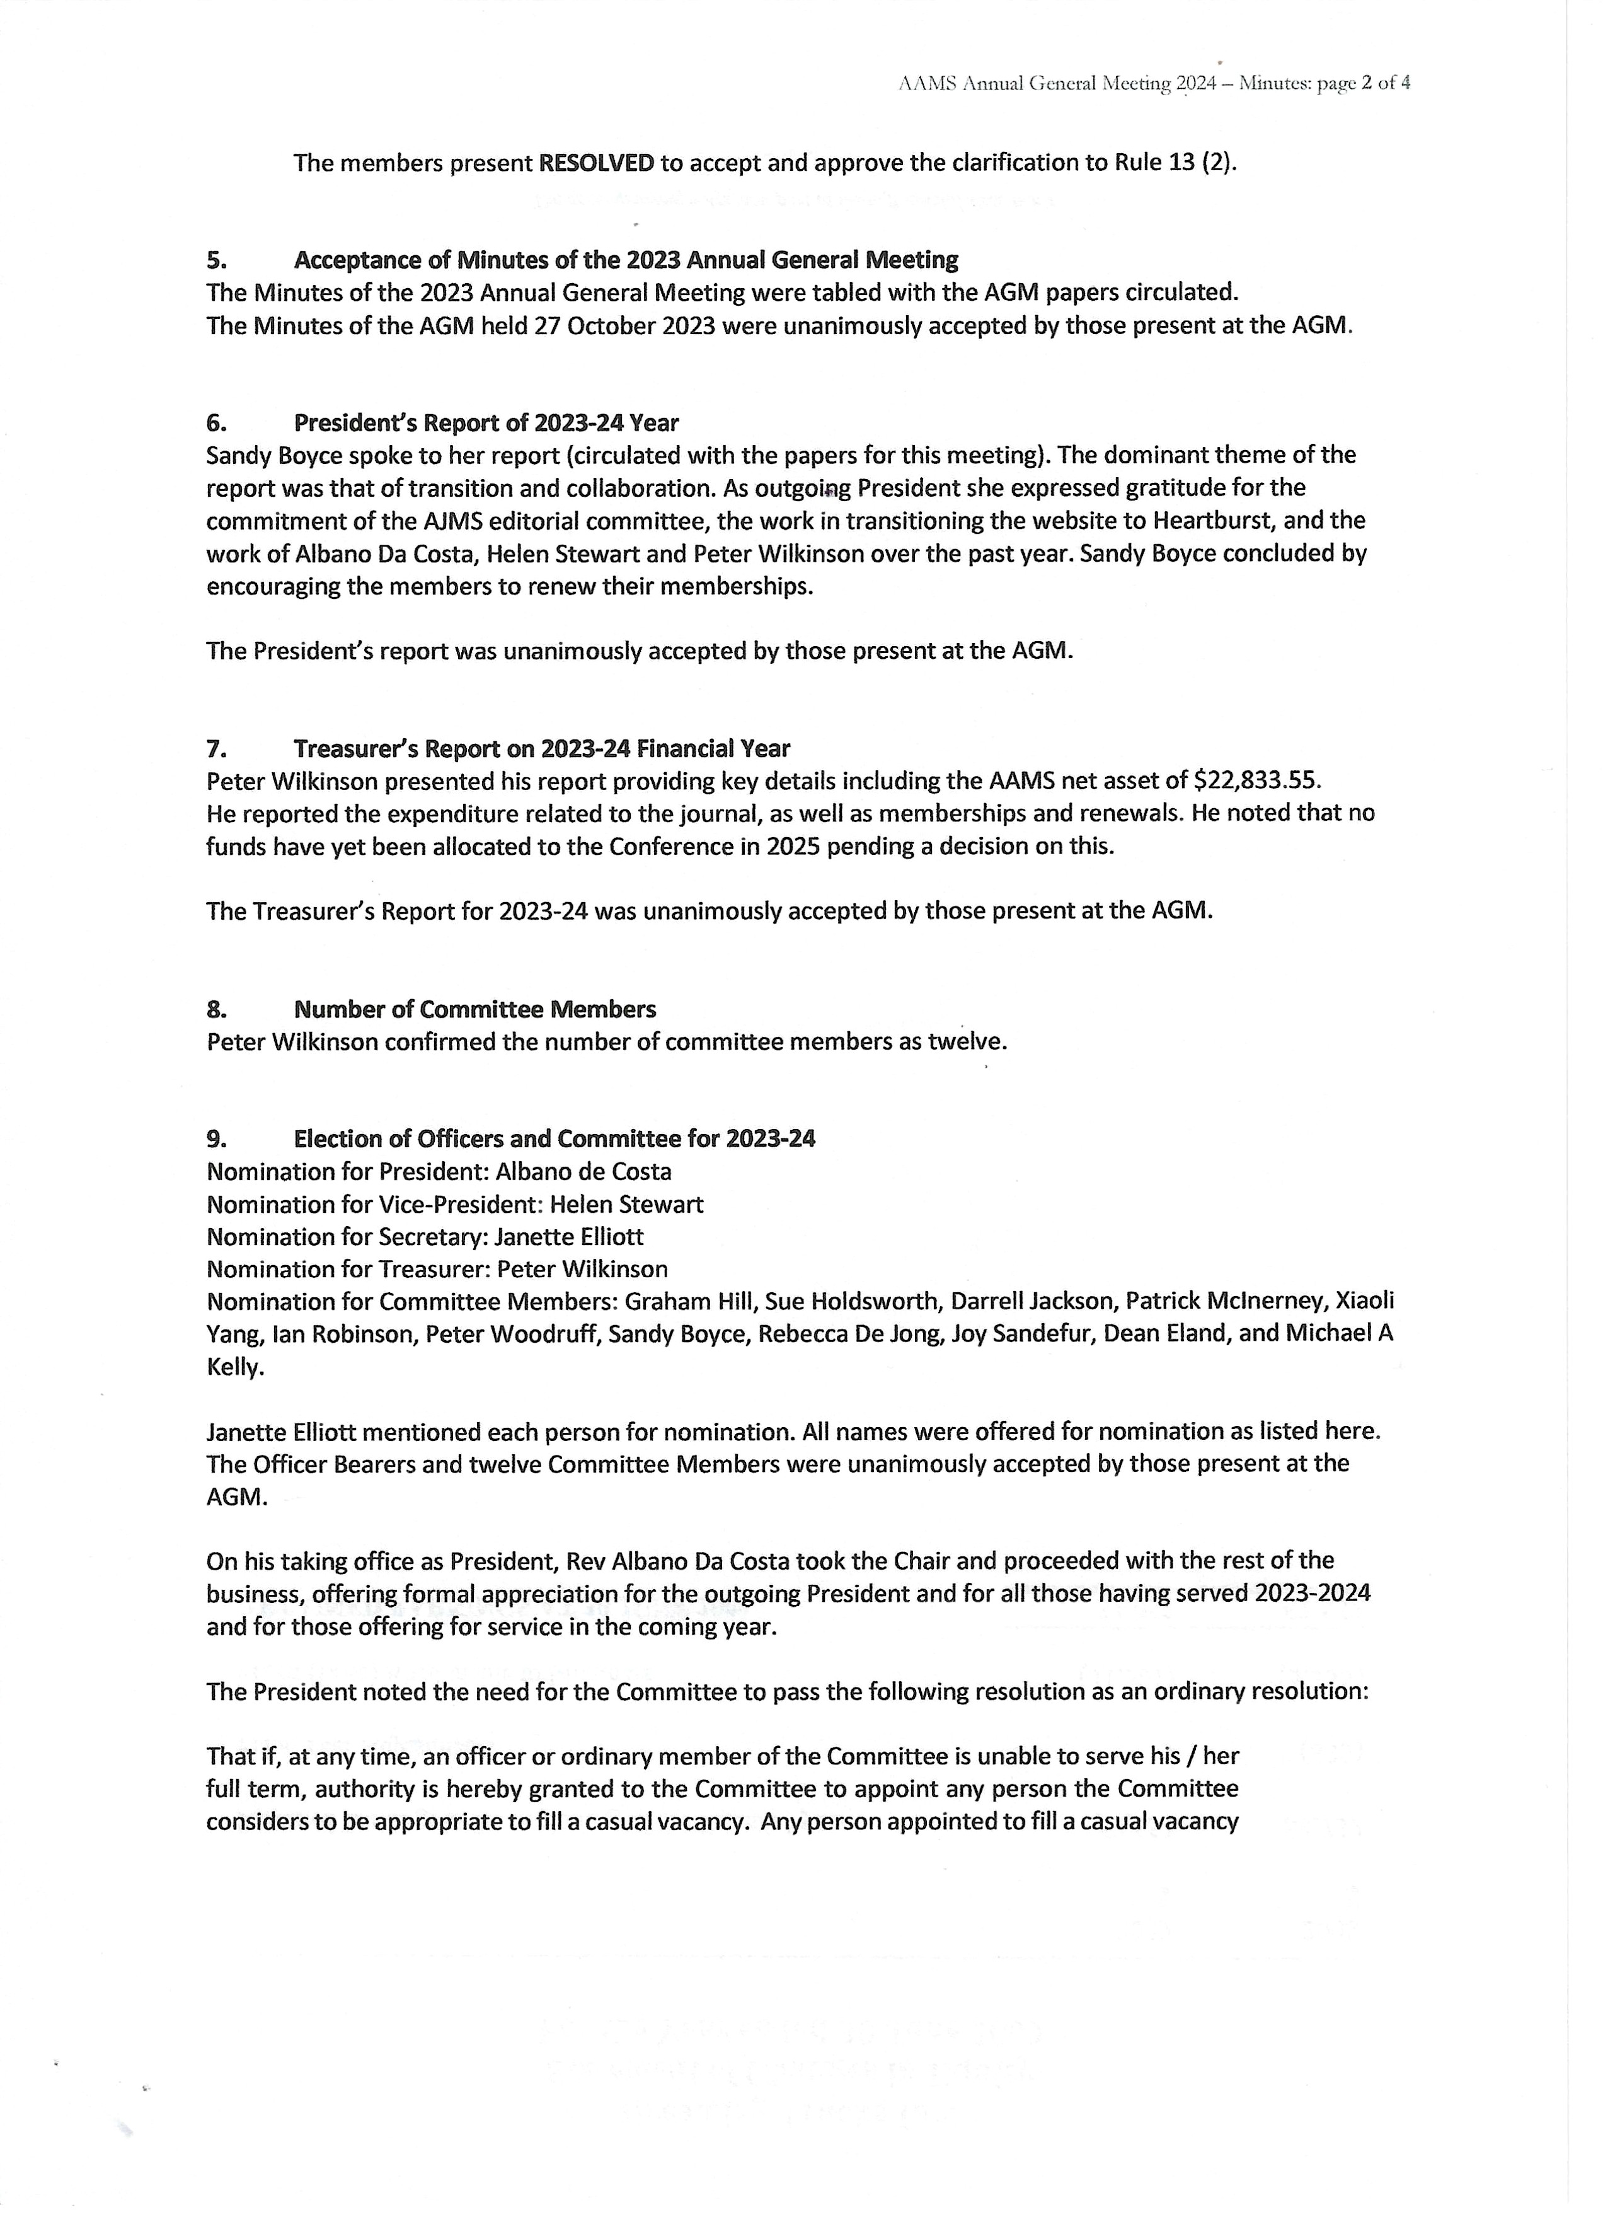

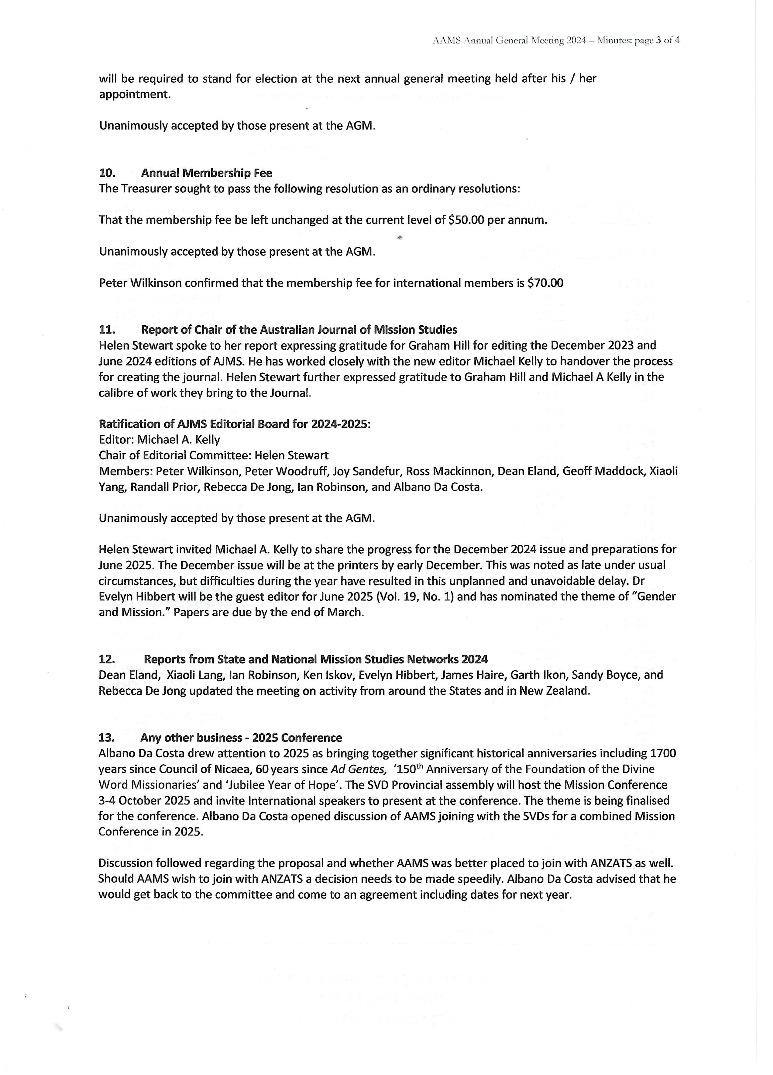



Associations Incorporation Reform Regulations 2023 S.R. No. 116/2023
Schedule 4—Model rules for an incorporated association

13 General rights of members
(1) A member of the Association who is entitled to vote has the right—
(a) to receive notice of general meetings and of proposed special resolutions in the manner and time prescribed by these Rules; and
(b) to submit items of business for consideration at a general meeting; and
(c) to attend and be heard at general meetings; and
(d) to vote at a general meeting; and
(e) to have access to the minutes of general meetings and other documents of the Association as provided under rule 75; and
(f) to inspect the register of members.
(2) A member is entitled to vote if—
(a) the member is a member other than an associate member; and Authorised by the Chief Parliamentary Counsel Schedule 4—Model rules for an incorporated association Associations Incorporation Reform Regulations 2023 S.R. No. 116/2023 33
(b) more than 10 business days have passed since the member became a member of the Association; and
(c) the member's membership rights are not suspended for any reason.

Part 4—General meetings of the Association
30 Annual general meetings
(1) The Committee must convene an annual general meeting of the Association to be held within 5 months after the end of each financial year.
(2) Despite subrule (1), the Association may hold its first annual general meeting at any time within 18 months after its incorporation.
(3) The Committee may determine the date, time and place of the annual general meeting.
(4) The ordinary business of the annual general meeting is as follows— (a) to confirm the minutes of the previous annual general meeting and of any special general meeting or general meeting held since then; (b) to receive and consider— (i) the annual report of the Committee on the activities of the Association during the preceding financial year; and (ii) the financial statements of the Association for the preceding financial year submitted by the Committee in accordance with Part 7 of the Act; (c) to elect the members of the Committee; (d) to determine the process for setting the amounts (if any) of the annual subscription and joining fee.
(5) The annual general meeting may also conduct any other business of which notice has been given in accordance with these Rules

33 Notice of general meetings
- The Secretary (or, in the case of a special general meeting convened under rule 32(3), the members convening the meeting) must give to each member of the Association— (a) at least 21 days' notice of a general meeting if a special resolution is to be proposed at the meeting; or (b) at least 14 days' notice of a general meeting in any other case.
- The notice must— (a) specify the date, time and place of the meeting; and (b) indicate the general nature of each item of business to be considered at the meeting; and (c) if a special resolution is to be proposed— (i) state in full the proposed resolution; and (ii) state the intention to propose the resolution as a special resolution; and (d) comply with rule 34(5).

34 Proxies
- A member may appoint another member as the member's proxy to vote and speak on the member's behalf at a general meeting other than at a disciplinary appeal meeting.
- The appointment of a proxy must be in writing and signed by the member making the appointment.
- The member appointing the proxy may give specific directions as to how the proxy is to vote on the member's behalf, otherwise the proxy may vote on behalf of the member in any matter as the proxy sees fit.
- If the Committee has approved a form for the appointment of a proxy, the member may use any other form that clearly identifies the person appointed as the member's proxy and that has been signed by the member.
- Notice of a general meeting given to a member under rule 33 must— (a) state that the member may appoint another member as a proxy for the meeting; and (b) include a copy of any form that the Committee has approved for the appointment of a proxy.
- A form appointing a proxy must be given to the Chairperson of the meeting before or at the commencement of the meeting.
- A form appointing a proxy sent by post or electronically is of no effect unless it is received by the Association no later than 24 hours before the commencement of the meeting.

35 Use of technology
(1) A general meeting may be held and members may take part by the use of technology that allows members to clearly and simultaneously communicate with each other participating member.
(2) For the purposes of this Part, a member participating in a general meeting as permitted under subrule (1) is taken to be present at the meeting and, if the member votes at the meeting, is taken to have voted in person.



Nomination Form for election to the Committee of the Australian Association for Mission Studies

(Apart from signatures, this form may be filled electronically)

We, (1)
(name of first nominator) (signature)

and

(2)
(name of second nominator) (signature)

being members of the Australian Association for Mission Studies (AAMS)

nominate
(name of nominee)

also a member of AAMS

to the AAMS Committee position of

(either President, Vice-President, Secretary, Treasurer, Editor or Member)

Signature of nominee, indicating consent

(nominee’s signature)

Date
(date of nomination)

Form of Proxy

I, being a member of Catholics for Renewal Inc. hereby appoint
being a member of Catholics for Renewal Inc, or or failing him/her
being a member of Catholics for Renewal Inc
as my proxy to vote for me on my behalf at the Annual General Meeting of Catholics for Renewal Inc. to be held on Wednesday 27 November 2025 and at any adjournment thereof.
My proxy is hereby authorised to vote in favour of / against the following resolutions:
- To confirm the minutes of the previous annual general meeting
In favour of / against (Strike out whichever is not desired)
- To receive from the Committee reports upon the activities of the Association during the preceding financial year (the President’s Report) In favour of / against (Strike out whichever is not desired)
To note that the Association is still a tier one association under the Associations Incorporation Act and to pass the following resolution as an ordinary resolution: That the financial statements need not be subject to audit or an independent review under the Australian Auditing Standards on Review Engagements. In favour of / against (Strike out whichever is not desired)
- To receive and consider the financial statements of the Association for the financial year ended 30 June 2020. In favour of / against (Strike out whichever is not desired)
- To pass the following resolution as an ordinary resolution: That the number of ordinary members of the Committee be a number determined by the Committee from time to time. In favour of / against (Strike out whichever is not desired)
- To vote in favour of the following nominees as officers of Catholics for Renewal Inc. as follows:
President --
Vice President --
Secretary --
Treasurer --
and the ordinary members of the Committee as follows: In favour of / against (Strike out whichever is not desired)

Signed this day of November 2025
Signature
Note: In the event of the Member desiring to vote for or against any resolution he or she shall instruct his or her proxy accordingly. Unless otherwise instructed, the proxy may vote as she/he thinks fit.
Each member is entitled to appoint another member as a proxy by notice given to the Secretary no later than 24 hours before the time of the meeting in respect of which the proxy is appointed. Such notice may be given to the Secretary by scanning the signed proxy form and sending it by email to the Secretary (Rose-Marie Prosser).

